|  |  |  |
| --- | --- | --- |
| BRR | March 2  2016 | |
| Making Facility Management more intelligent and efficient. | | Business Requirements Review |

|  |  |  |  |
| --- | --- | --- | --- |
| **Revision record** | | | |
| Version | Date | Attendees | Comment |
| 1.0 | 10.02.16 | Arshad Shakil,  Badis Madani,  [Håkon Hedlund](https://www.facebook.com/hakon.hedlund)**,**  Zhili Shao |  |
| 1.2 | 16.02.16 | Arshad Shakil,  Badis Madani,  [Håkon Hedlund](https://www.facebook.com/hakon.hedlund)**,**  Zhili Shao | Add new content to FM description, FM patterns and their problems. Also, add some comments and references. |
| 1.3 | 02.03.16 | Arshad Shakil,  Badis Madani,  [Håkon Hedlund](https://www.facebook.com/hakon.hedlund)**,**  Zhili Shao | Change some contents according to Pro.Aurilla’s comments. |
| 1.4 | 2.05.16 | Håkon Hedlund,  Badis Madani | Corrected grammar, and rephrased. |

Contents

1. Introduction 3

1. Facility Management 3

2. HVAC System 5

3. Advantages of Current Large Commercial HVAC System 7

4. Disadvantages/Limitations of Large Commercial HVAC System 8

5. Requirements and Trends 8

2. Problem formulation 9

# Introduction

## 1. Facility Management

Facility Management (FM) is the integration of processes within an organization (like school, hotel, hospital, department complexes and so on) to maintain and develop the agreed services which support and improve the effectiveness of its primary activities.

FM represents a wider range of activities than just business services and these are referred to as non-core functions. They vary from one business sector to another. In a 2009 Global Job Task Analysis the [International Facility Management Association](https://en.wikipedia.org/wiki/International_Facility_Management_Association) (IFMA) identified the core competencies of facility management as:

* Communication
* Emergency Preparedness and Business Continuity
* Environmental Stewardship and Sustainability
* Finance and Business
* Human Factors
* Leadership and Strategy
* Operations and Maintenance
* Project Management
* Quality
* Real Estate and Property Management
* Technology

## Facility Management services

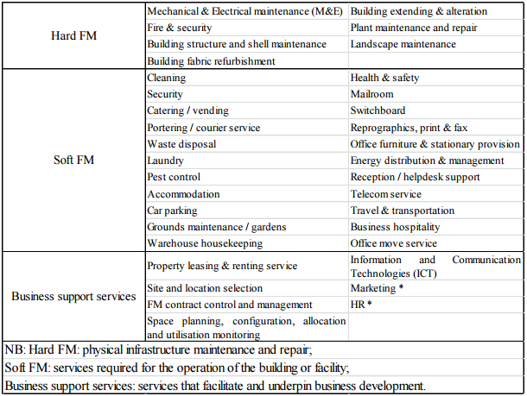

Table1.1 FM servicies

As we can see from the core competencies list, FM covers a wide field of activities related to the workplace, facility, support services, property, corporate real estate, and infrastructures. There are different classifications proposed by the academic researchers. Table1.1 is one common way of categorizing FM activities, it shows the boundaries of FM services, where the total FM (TFM) consists of hard FM, soft FM, and the other business support services.

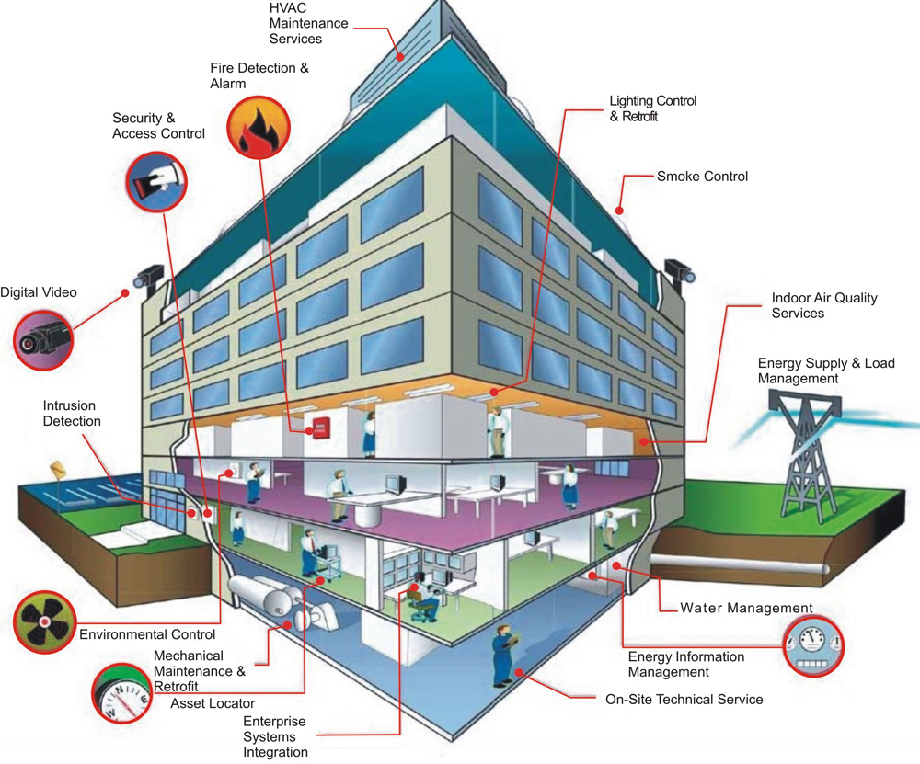

Figure 1.1 Hard FM

The Hard FM refers to physical infrastructure maintenance, it provides services about building management, which includes lighting control system, HVAC, Access control, Fire alarm, CCTV and so on. From Figure1.1, we can get an overview of the services contained by Hard FM.

In this Project, many services within the facility are discussed, but to focus the project area on one specific service to deal with so to make a progress, the team saw an opportunity when noticed in the HSN Krona building that different users (students, and employees) were not satisfied with their indoor environment (temperature, humidity, fresh air...) which reflects the behavior of the HVAC system in the building. The Team decided to focus on this service for the next coming project steps.

## HVAC System

HVAC system, which stands for heating, ventilation, and air conditioning, is one important FM service in almost every building. It controls temperature, humidity and air quality inside a building and provides a comfortable environment for users in the building.

Heating systems usually comprise of a boiler, furnace, heat pump or district hot water to heat water, steam or air. Piping distributes heated fluid and radiators transfer this heat to air and structures, e.g. floor heating system.

Ventilation is the process of “changing” or replacing air in any space to control temperature or remove moisture, smoke, carbon dioxide, etc. It includes both the exchange of air to the outside as well as circulation of air within the building. Supply air used for ventilation is filtered and cooled and/or heated inside air handling units.

Air conditioning systems are designed to stabilize the air temperature and humidity within an area. Excess heat from the circulating air is usually removed by a cooling coil that is supplied with cold water supplied by the chiller. To decrease relative humidity the circulating air needs to be cooled to a temperature below the dew point and then be heated back to meet the requirement.

Depending on the working methods of subsystems in HVAC system, there are four types of HVAC system:

1. Heating and Air Conditioning Split System

Split systems are the most classic of the heating and [air conditioning systems](http://www.servicechampions.net/products/cooling-air-conditioner/). These are the traditional types of HVAC system where you have components of the whole system that are both inside and outside the building.

1. Hybrid Heat Split System

The hybrid heat split system is an advanced version of the classic HVAC split system that has an improved energy efficacy. When included in these types of HVAC systems, a heat pump will allow the option of having an electrically fueled HVAC up and above the typical gas furnaces.

1. Duct-Free Split Heating & Air Conditioning System

A duct-free HVAC provides good installations for places and areas where the convectional systems with ducts can’t go. These systems are also ideally great compliments to existing ducted types of HVAC systems.

1. Packaged Heating & Air Conditioning System

A packaged HVAC system is the solution to those homes and offices without adequate spaces for all the separate multiple components of the split systems. Packaged heating and air conditioning systems will sort out confined spaces that range from entire homes to the one-roomed units, all in one package.

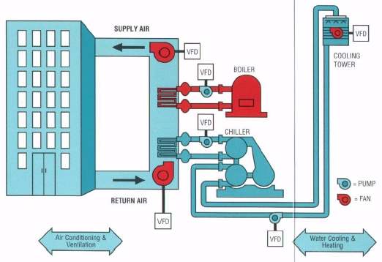

Figure2.1 Centralized HVAC system

Figure2.1 illustrates a specific HVAC system of one building, it demonstrates the basic principle of a centralized HVAC system.

## Advantages of Current Large Commercial HVAC System

Large centralized HVAC systems like Figure2.1 is almost used in every building like an office building, shopping mall, school, hospital, etc. There are many advantages of centralized HVAC system:

* Quick response to temperature changes
* Air filtration and adjusted humidity for comfortable, healthy indoor air
* Humidification and dehumidification with central air conditioning
* Year-round use for cleaning and circulating fresh air
* Safer indoor air quality than wood-burning stoves or inserts
* New technology with compact equipment and full automation
* Quiet operation with built-in vents and registers
* Lower fuel costs with heat pump options

## Disadvantages/Limitations of Large Commercial HVAC System

Except the advantages of large commercial HVAC System, there are some disadvantages exist:

* Expensive to install
* High maintenance costs and potential leakage problems
* Efficiency is poor, operation cost is high

## HVAC Control System

In simplest term, the control is defined as the starting, stopping or regulation of heating, ventilating,

and air conditioning system. Controlling an HVAC system involves three distinct steps:

1) Measure a variable and collect data

2) Process the data with other information

3) Cause a control action

The above three functions are met through sensor, controller and the controlled device.

## Requirements and Trends

The traditional HVAC system needs an improvement to optimize users’ experience and make maintainers’ work efficient with the fast developing new technology.

For the HVAC users, a comfortable customized indoor environment is needed. The HVAC control system should be intelligent enough to make the setting process easy. There should be more methods for system configuration than the existing thermostat control panel. Also for the configuration strategies, more factors such as time, weather should be added. In order to make the system work automatically, some algorithms can be designed to adjust the indoor environment.

For the HVAC maintainers, they always have a responsibility to concern about the maintenance of the HVAC system. They inspect the system periodically to make sure the HVAC system works as expected. If there’s a problem with the HVAC system, they often spend a long time on troubleshooting in order to fix the problem. So a good troubleshooting mechanism will help them a lot.

These requirements about HVAC control system has existed for a long time. Now new technology gives us more possibility to solve them.

The Internet of things, which is known as IoT, is the network of physical objects—devices, vehicles, buildings and other items embedded with electronics, software, sensors, and network connectivity—that enables these objects to collect and exchange data.

Cloud computing, also on-demand computing, is a kind of Internet-based computing that provides shared processing resources and data to computers and other devices on demand. It has become a highly demanded service or utility due to the advantages of high computing power, cheap cost of services, high performance, scalability, accessibility as well as availability.

Big data is a term that describes the large volume of data – both structured and unstructured – that inundates a business on a day-to-day basis. But it’s not the amount of data that’s important. It’s what organizations do with the data that matters. Big data can be analyzed for insights that lead to better decisions and strategic business moves.

These new technologies will bring revolution to the FM markets, also for the traditional HVAC control system, they will bring new solutions for the requirements of users and maintainers.

# Problem formulation

As mentioned in the requirements and trends part, the traditional HVAC system needs an improvement to optimize users’ experience by customizing the indoor environment (temperature, humidity and CO2 level), and add some factors such as time and weather to the configuration strategies.

The improved system also needs to take into account factors like energy saving, easiness of use, easiness of installation, initial and lifecycle cost.